Protocols and Recipes

Zahavah Rojer

Hendry Lab

**Table of Contents**

Planting & Aphids 3

*Pseudomonas* Epiphytic Growth Assays 5

Glycerol Stocks 7

King’s Broth (KB) Media (500 mL) 8

-80°C Freezer Strain Retrieval 9

MgCl2 (1M) Stock 10

Creating *Pseudamonas* Mutants 11

Primer construction: 12

BP reaction 13

LR reaction 13

# Planting & Aphids

## Date Updated: 2023 November 13

Procedure:

1. Evaluate plants
   * Dryness
   * Deadness
   * Aphid contamination
     + If you find an aphid: text Tory or Katie.
     + Isolate the plant, ideally in an aphid cage.
     + Check if there is a backup of that plant.
       - If so, plant may have to be moved to the aphid room.
     + *Note: never go into the plant room after being in the aphid room on the same day.*
2. Pots
   * Clear the sink.
   * Empty soil from the old pots (after freezing) into the trash bag.
     + *Note: do not leave defrosting trash bags out for >3 days.*
   * Place empty old pots in sink and scrub/rinse to remove dirt.
   * Add 1:10 bleach to water (by eye) into a tub in the sink and soak scrubbed/rinsed pots for ~12 hours.
   * Rinse off the bleach from the pots and set on bench to dry.
     + *Note: be careful not to get bleach on clothes or hands.*
3. Planting
   * Use dry pots with two trays underneath and up to 6 pots/tray.
     + Use smaller pots for plants like fava bean/pea and bigger pots for plants like barley/cucumber.
   * Loosen a bag of soil and fill pots up to inner rim.
   * Seeds are located in the fridge on the second shelf.
     + Use Johnny’s seeds.
   * Plant seeds according to the post-it note on the countertop shelf.

|  |  |
| --- | --- |
| Cucumbers | 3 seeds/pot |
| Beans | 4 beans/pot |
| Turnips | 1 pinch/pot |
| Barley | 1 pinch/pot |
| Dock | 1 pinch/pot |

* + - *Note: calculate any fava plants 2 weeks before experiments*
    - *Note: always make sure there are at least 12 fava bean plants for the aphids.*

1. Watering
   * The hose is in the adjacent room.
   * Turn on the tap in the adjacent room and the switch for the water in located on the hose nozzle.
   * 3 secs/plant on high setting.
2. Sacrificing Plants to the Aphids
   * Info in on door

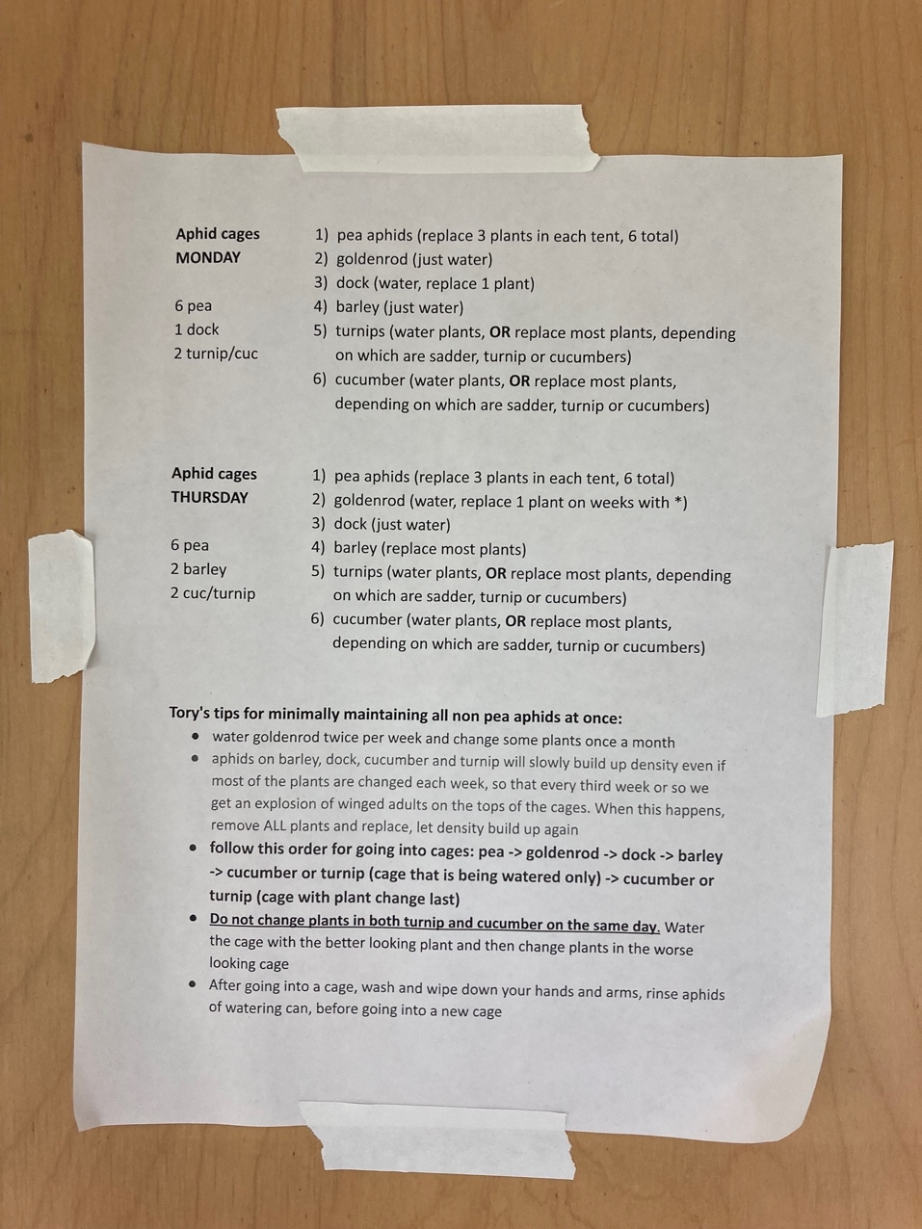

* + Take out ¾ of the plants in a cage and put them in a trash bag.
    - Use a different trash bag for each aphid species.
  + Replace those 3 with fresh plants.
  + When watering plants, wash can between aphid cages.

# *Pseudomonas* Epiphytic Growth Assays

## Date Updated: 2023 November 24

**Day -3: Plating**

1. From -80C/current plate, plate *Pseudomonas* strains/individual colonies on KB + NA (15 ug/mL) + NFT (50 ug/mL) plates.
2. Incubate for 24-72 hours at 28C.

**Day 0: Overnights of *Pseudomonas***

1. Pipette 10 mL of KB + NA (15 ug/mL) + NFT (50 ug/mL) media in 15 mL culture tube.
   1. *Note: Make 1 tube/pot and don’t forget a blank!*
2. Transfer a colony of *Pseudomonas* from plate to media.
3. Incubate in benchtop shaker at 28C overnight (~18 hrs).

**Day 1: Spraying**

1. Transfer overnight *Pseudomonas* culture from culture tube to falcon tube.
2. Pellet cells by centrifuging for 10 min on max speed
3. Discard supernatant.
4. Add 1 mL 10mM MgCl2 buffer and resuspend/vortex.
5. Pellet and discard supernatant again.
6. Add ~25 mL 10mM MgCl2 buffer and resuspend/vortex.
7. Transfer 100 ul of sample to a blank cuvette.
8. Measure OD of bacterial resuspension (include blank!).
   1. Goal: OD = 0.2
9. Transfer 20 mL of bacterial resuspension into autoclaved spray bottle.
   1. Clean tops using ethanol and sterile water.
10. Retrieve 14 day old plants from plant room and place in biosafety cabinet.
11. Spray ~20 mL bacterial solution onto all the leaves and all plant surfaces (stem, top, bottom) of pot until runoff (starting to drip).
12. Allow plant to dry in the biosafety cabinet.
13. Move plant to tent downstairs and note time.
14. Incubate for 72 hours in a tent at 70F and 85% humidity.

**Day 4: Sampling**

1. Retrieve plants from plant room and place in biosafety cabinet.
2. Sterilize cork borer and forceps using ethanol flame and place in a sterile petri dish in biosafety cabinet.
3. Take 10 samples from all over each plant in the pot.
   * Place all samples from a plant in a single falcon tube, 10 discs/tube.
     + Will end with end with 3 falcon tubes and 30 samples if sampling 3 plants (1 pot).
   * Add 10 mL of 10mM MgCl2 buffer to falcon tubes.
4. Sonicate falcon tubes for 10 min.
5. Vortex to dislodge epiphytic bacteria.
6. Make serial dilutions (2 technical replicate/sample) in 96 well plate using multichannel pipette.
   * 900 uL buffer and 100 uL sample/dilution.
7. Plate serial dilutions on KB + NA (15 ug/mL) + NFT (50 ug/mL) plates.
   * 4 plates per sample
   * 100 ul per plate
8. Allow plates to dry then flip upside and incubate at 28C for 24 hrs.

**Day 5: Counting**

1. Photograph plates.
2. Count colonies on each plate and note in spreadsheet.
3. Calculate CFU/10 mL bacterial resuspension (ie. per sample).

# Glycerol Stocks

## Date Updated: 2022 November 4 by Vivi Sanchez

1. Add 1mL of LB to sterile glass culture tube.
2. Select one colony of interest from your nutrient plate and inoculate culture media.
3. Grow culture overnight at 28°C in shaker.
4. The next day, label 2 cryotubes with isolate information on the side of the tube (i.e Isolate ID, isolate name, date collected, Collector) and label the top of the tube with the Isolate ID.
5. Check the -80°C master sheet on Lab archives to determine Isolate ID.
6. Dispense 900 uL of sterile 20% glycerol in each cryotube.
7. Dispense 100 uL of overnight culture to its designated cryotube.
8. Invert to mix and let sit for at least five minutes.
9. Store at -80°C.

# King’s Broth (KB) Media (500 mL)

Ingredients:

|  |  |
| --- | --- |
| ddH2O | 500mL |
| Peptone | 10 g |
| K2HPO4 | 0.75 g |
| MgSO4•7H2O | 0.75 g |
| Glycerol | 5.0 ml |
| Agar (if needed) | 7.5 g |

Procedure:

1. Measure 500 ml DI water into a 1 L glass media bottle.
2. Add ingredients in order above (use syringe for glycerol) and swirl to mix.
3. Autoclave on liquid run for 30 mins.
4. Place in waterbath at 56ºC until cool enough to pour.
5. If adding antibiotics/antifungals, wait until bottle is temperature of a warm cup of tea before adding.

# -80°C Freezer Strain Retrieval

## Date Updated: 2022 November 4 by Vivi Sanchez

1. Grab -80°C freezer key from its designated drawer in room 257.
   1. Please remember to return the key to this spot when you are done using it.
2. Fill an ice bucket with ice and retrieve stocks of interest.
   1. Glycerol stocks will thaw quickly, so please remove a few stocks at a time to prevent unnecessary thawing.
3. Plate stocks on LB and incubate overnight at 28°C.
4. Return stocks to -80°C freezer and return key to its drawer.
5. Check pockets to make sure you did not accidentally take the key. :)

# MgCl2 (1M) Stock

Ingredients:

|  |  |
| --- | --- |
| MgCl2 anhydrous (Molecular weight = 95.21) | 19.04 g |
| dH2O | 200 mL |

Procedure:

1. In the fume hood, dissolve MgCl2 in dH2O
   1. Note: this is an exothermic reaction and it will heat up.
2. Autoclave on fluid for 30 mins.

# Creating *Pseudamonas* Mutants

pMTN1907 is a GatewayTM ready destination vector first published in (Baltrus et al. MPMI 2012). For more information on GatewayTM technologies, please see the following links (Link 1, Link 2, Link 3).

The main features of pMTN1907 are attR sites which enable recombination between an entry vector and pMTN1907, selection for tetracyline resistance (10ng/uL in *P. syringae*), and selection for sucrose sensitivity (5% sucrose for *P. syringae*). The *sacB* ORF enabling negative selection on sucrose is driven by a *trp* promoter which enables strong selection in all strains tested regardless of chromosomal insertion site. pMTN1907 also contains an ORF providing kanamycin resistance, but we’ve found that this gene in it’s current form is not active in *P. syringae* (although kanR mutants can be selected).

The first step to making mutations with pMTN1907 is to clone a PCR fragment into a GatewayTM ready entry vector such as pDONR207. This PCR fragment should consist of what you would ultimately like the genome to look like. Therefore, if you are seeking to make a site-specific mutation, clone a fragment that exactly resembles the genome except for the specific site of interest (Fig. 1). If you are interested in making a clean deletion, clone a fragment that consists of the upstream and downstream portions of the genome, but which lacks the gene of interest (Fig.1). Since pMTN1907 ultimately requires recombination (Fig. 3) into the chromosome, larger sized fragments will be easier to recombine into the chromosome (I typically try to have at least 200bp on each side of the mutation of interest).

*Figure 1. Primer Design for pMTN1907 based mutagenesis*

In my experience, the easiest way to construct these fragments is though overlap extension PCR. Design primers to amplify regions upstream and and downstream of the mutation of interest. If you are making a clean deletion, simply amplify regions immediately upstream and downstream of the gene (see figure 1). If you are making a site specific mutation, amplify regions upstream and downstream of the nucleotide you are interested in modifying. In each case, internal primers for these reactions should include enough overlap so that the fragments they generate can hybridize during the second PCR reaction. I’ve found that at least 15 nucleotides of overlap is minimally sufficient (blue squiggles in Fig. 1). If you are interested in making a site specific mutation, simply build this mutation into the PCR primers.

# Primer construction:

To clone this fragment into the initial entry vector, these fragments must be flanked by additional nucleotide sequences that can be recognized by BP clonase. Since these nucleotide regions are somewhat large, I only add a small tail to the first set of primers. In figure 1, I show two primer pairs to amplify the regions of interest. Only include the small tails (red squiggles) on the most external primer pairs (flanking the whole region in figure 1, A and #1) and place these tails on the 5’ ends of the primers. The primer tails have the following sequences:

5’ Forward primer: CAAAAAAGCAGGCTCC 3’ Reverse primer: GAAAGCTGGGTG

*Figure 2: Schematic of Overlap PCR*

When you perform the second PCR reaction, to fuse upstream and downstream regions together using overlap extension (see Figure 2), use a second set of tailing primers only which can bind to the small tails mentioned above (Tailing primers):

5’ Forward primer: CAAAAAAGCAGGCTCC 3’ Reverse primer: GAAAGCTGGGTG

Once you have this construct made and tailed, you are ready to use BP clonase to recombine into a GatewayTM entry vector. ***Be sure to column purify the PCR reaction or you can have problems by cloning just the primers. I’ve also found that the BP reaction also works after gel purification of the PCR products, so use this if there are multiple product bands in your PCR reaction.

# BP reaction

The BP reaction is straightforward. In my experience you can use 6uL total for the reaction, with 1uL of BP clonase and 1uL of 100ng/uL entry vector (pDONR207 usually). Fill the remaining space with 100ng or so of your PCR product. Incubate on your benchtop for at least 15 minutes and transform into *E. coli* cells. Be sure to use *E. coli* cells that are susceptible to the *ccdB* toxin or you will get back a lawn of bacteria that contain unchanged entry vector.

# LR reaction

The LR reaction is just like the BP reaction, but you use pMTN1907 as the destination vector instead of pDONR207.. In my experience you can use 6uL total for the reaction, with 1uL of LR clonase and 1uL of 100ng/uL entry vector containing your cloned fragment which you have plasmid purified away from *E. coli* cells, and 1uL of 100ng/uL of pMTN1907. The LR reaction is fairly robust to differences in these concentrations. Incubate on your benchtop for at least 15 minutes and transform into *E. coli* cells. Again, be sure to use *E. coli* cells that are susceptible to the *ccdB* toxin or you will get back a lawn of bacteria that contain unchanged entry vector.

**Mating into *P. syringae***

If you have successfully cloned your fragment into pMTN1907, the remaining portions of the protocol consist of mating bacterial strains. Mix *E. coli* containing your destination vector with the *P. syringae* strain of interest (as well as with a conjugation helper strain like pRK2013 if necessary). I find that a 1:1:0.5 mix (*E. coli:P.syringae:*helper) works just as well as anything else. Plate this strain combination on nonselective media at 27oC for at least a day then streak or plate out the mixture on selective media. If your *P. syringae* strain has not been selected for resistance to antibiotics, you can plate out on nitrofurantoin to prevent any *E. coli* from growing (*Pseudomonads* are naturally resistant). Also include 10ng/uL tetracycline in these plates to select for integration of pMTN1907 into the *P. syringae* chromosome.

*Figure 3: Recombination into* P. syringae *chromosome*

Since pMTN1907 doesn’t replicate in *P. syringae*, the only way that strains can have resistance to tetracycline after mating with this plasmid is if the plasmid has been recombined into the chromosome (Figure 3). If this happens, the chromosome of *P. syringae* in your region of interest should look like figure 3 depending on which side of the fragment recombination started on. Basically, there will be a local duplication of your region of interest except that one copy will consist of the fragment you cloned.

At this point, you simply need to grow up *P. syringae* strains containing the integration overnight in liquid media lacking tetracycline, and plate on agar containing 5% sucrose by weight. The only strains that can grow will be those that recombine pMTN1907 back out of the chromosome (because of the presence of *sacB* in pMTN1907). Recombination has two possible resolutions, either the wild type form or the form of the fragment you cloned (Figure 4). If you are selecting for a clean deletion you can screen through sucrose resistant colonies by PCR and look for smaller fragments (containing the gene deletion). If it is a site specific mutant, you either need to sequence the region from multiple colonies or design a restriction enzyme based assay that can discriminate between the wild type sequence and your site specific mutant after PCR. I’ve found that success flipping out to the mutant form is dependent on size of the flanking region, with larger regions giving you a better chance of isolating a strain with your mutation, but I’ve never had to screen more than about 50 colonies or so to find what I’m looking for.

*Figure 4*. *Recombinatorial resolution after integration and selection on sucrose*

Designing the deletion construct:

1. Design 4 primers. 2 to amplify a 0.8-1.0 kb fragment 5’ of the region to be deleted, and 2 to amplify a 0.8-1.0 kb fragment 3’ of the region to be deleted. For the primers away from the deletion region (5’ primer for the 5’ fragment and 3’ primer for the 3’ fragment) add the following sequences:
   * 5’ fragment: 5’-CAAAAAAGCAGGCTCC-primer-3’
   * 3’ fragment: 5’-GAAAGCTGGGTG-primer-3’
2. For the primers immediately adjacent to the deletion region, add the reverse complement of each primer to the 5’ end of the other. For example, if the 3’ antisense primer for the 5’ fragment is ACTCGC (primer 1) and the 5’ sense primer for the 3’ fragment is TTACGT (primer 2) then they should look like the following:
   * Primer 1: 5’-ACGTAAACTCGC-3’
   * Primer 2: 5’-GCGAGTTTACGT-3’
3. By doing this, the primers near the deletion region will generate fragments with tails that can prime off of each other to generate a construct where the 5’ fragment and the 3’ fragment are physically linked, with the intervening deletion region absent.
4. Amplify and purify both fragments. When performing the initial amplification to generate the 5’ and 3’ fragments, calculate the annealing temperature based on the sequence that will actually pair for the amplification (i.e. do not include either the red or blue sequences above in the Tm calculation). Amplify both products and either perform a PCR clean-up (run out 5 µl to ensure a single amplicon that is the correct size for both fragments) or, if the PCR does not yield a single product, then run the full reactions out, excise and gel purify the correct fragments.
5. Set up a PCR reaction that includes both fragments (10-50 ng each, more or less may work as well) but omits any primers. Run that reaction as a normal PCR for 10 cycles with an annealing temp calculated based on the Tm of the overlapping sequence. Following the 10 cycles, pause the reaction at 4 °C, spike in the following primers:
   * BP tailing primer F: 5’-GGGGACAAGTTTGTACAAAAAAGCAGGCTCC-3’ BP tailing primer R: 5’-GGGGACCACTTTGTACAAGAAAGCTGGGTG-3’
6. Following the addition of the primers, continue the reaction for an additional 20 cycles with a Tm of 55-58°C. For the second amplification, gel purify the fragment (which is size of the sum of both individual fragments).
7. Use the purified fragment in a BP clonase reaction (<https://www.thermofisher.com/order/catalog/product/11789020>) with pDONR207 (Gent resistant, 25 µg/ml). Transform cloned reaction into *E. coli*. Screen gent resistant colonies for correct fragment using colony PCR.
8. Isolate the plasmid with the deletion construct and use in a downstream LR clonase reaction (<https://www.thermofisher.com/order/catalog/product/11791100>) with pMTN1907 (Kan resistant 50 µg/ml, Tet resistant). Transform the reaction into *E. coli* and again screen for kan resistant colonies with the correct fragment.
9. Isolate the plasmid and transform into *E. coli* strain S17-1 (a strain that can conjugate pMTN1907).
10. Perform a mating between S17-1 (harboring the the KO construct) and the target Pseudomonad. Combine S17-1 with the Pseudomonad at a rough ration of 1:6 and spot onto non-selective media (LB or KB). Incubate the plates at ~28 °C for 24-48 hrs.
11. Resuspend the bacteria from the plate into sterile 10 mM MgCl2 or other sterile buffer. Spread bacteria onto several plates of selective media (KB supplemented with Tet [10 µg/ml], nitrofurantoin [NFT, 50 µg/ml], and, if the Pseudomonad is rif resistant, rifampicin [50 µg/ml]. Incubate plates at 28 °C for 2-3 days. Pick several colonies and streak them out to fresh selective media to ensure those colonies grow robustly.
12. Inoculate 3-5 colonies into KB broth without any antibiotic amendment. Grow over night. Spread 50 µl of the undiluted culture and 50 µl of the culture diluted 1/10 onto KB agar, which has been amended with 5% sucrose.
13. Incubate the plates at 28 °C for 24 hours. Pick 3-6 colonies derived from each original broth culture, resuspend into 50 µl sterile broth. Inoculate 20 µl of each suspension into KB broth amended with tetracyclin e and inoculate 20 µl of each suspension into unamended KB broth. Discard any culture pair where there is growth in the presence of tetracycline. For any culture where there was no growth in the tetracycline tube, screen the unamemnded culture for the correct construct via PCR. It may be necessary to go back to the KB sucrose plate to screen additional colonies, if none of the initial colonies screened are confirmed to have the KO genotype.